

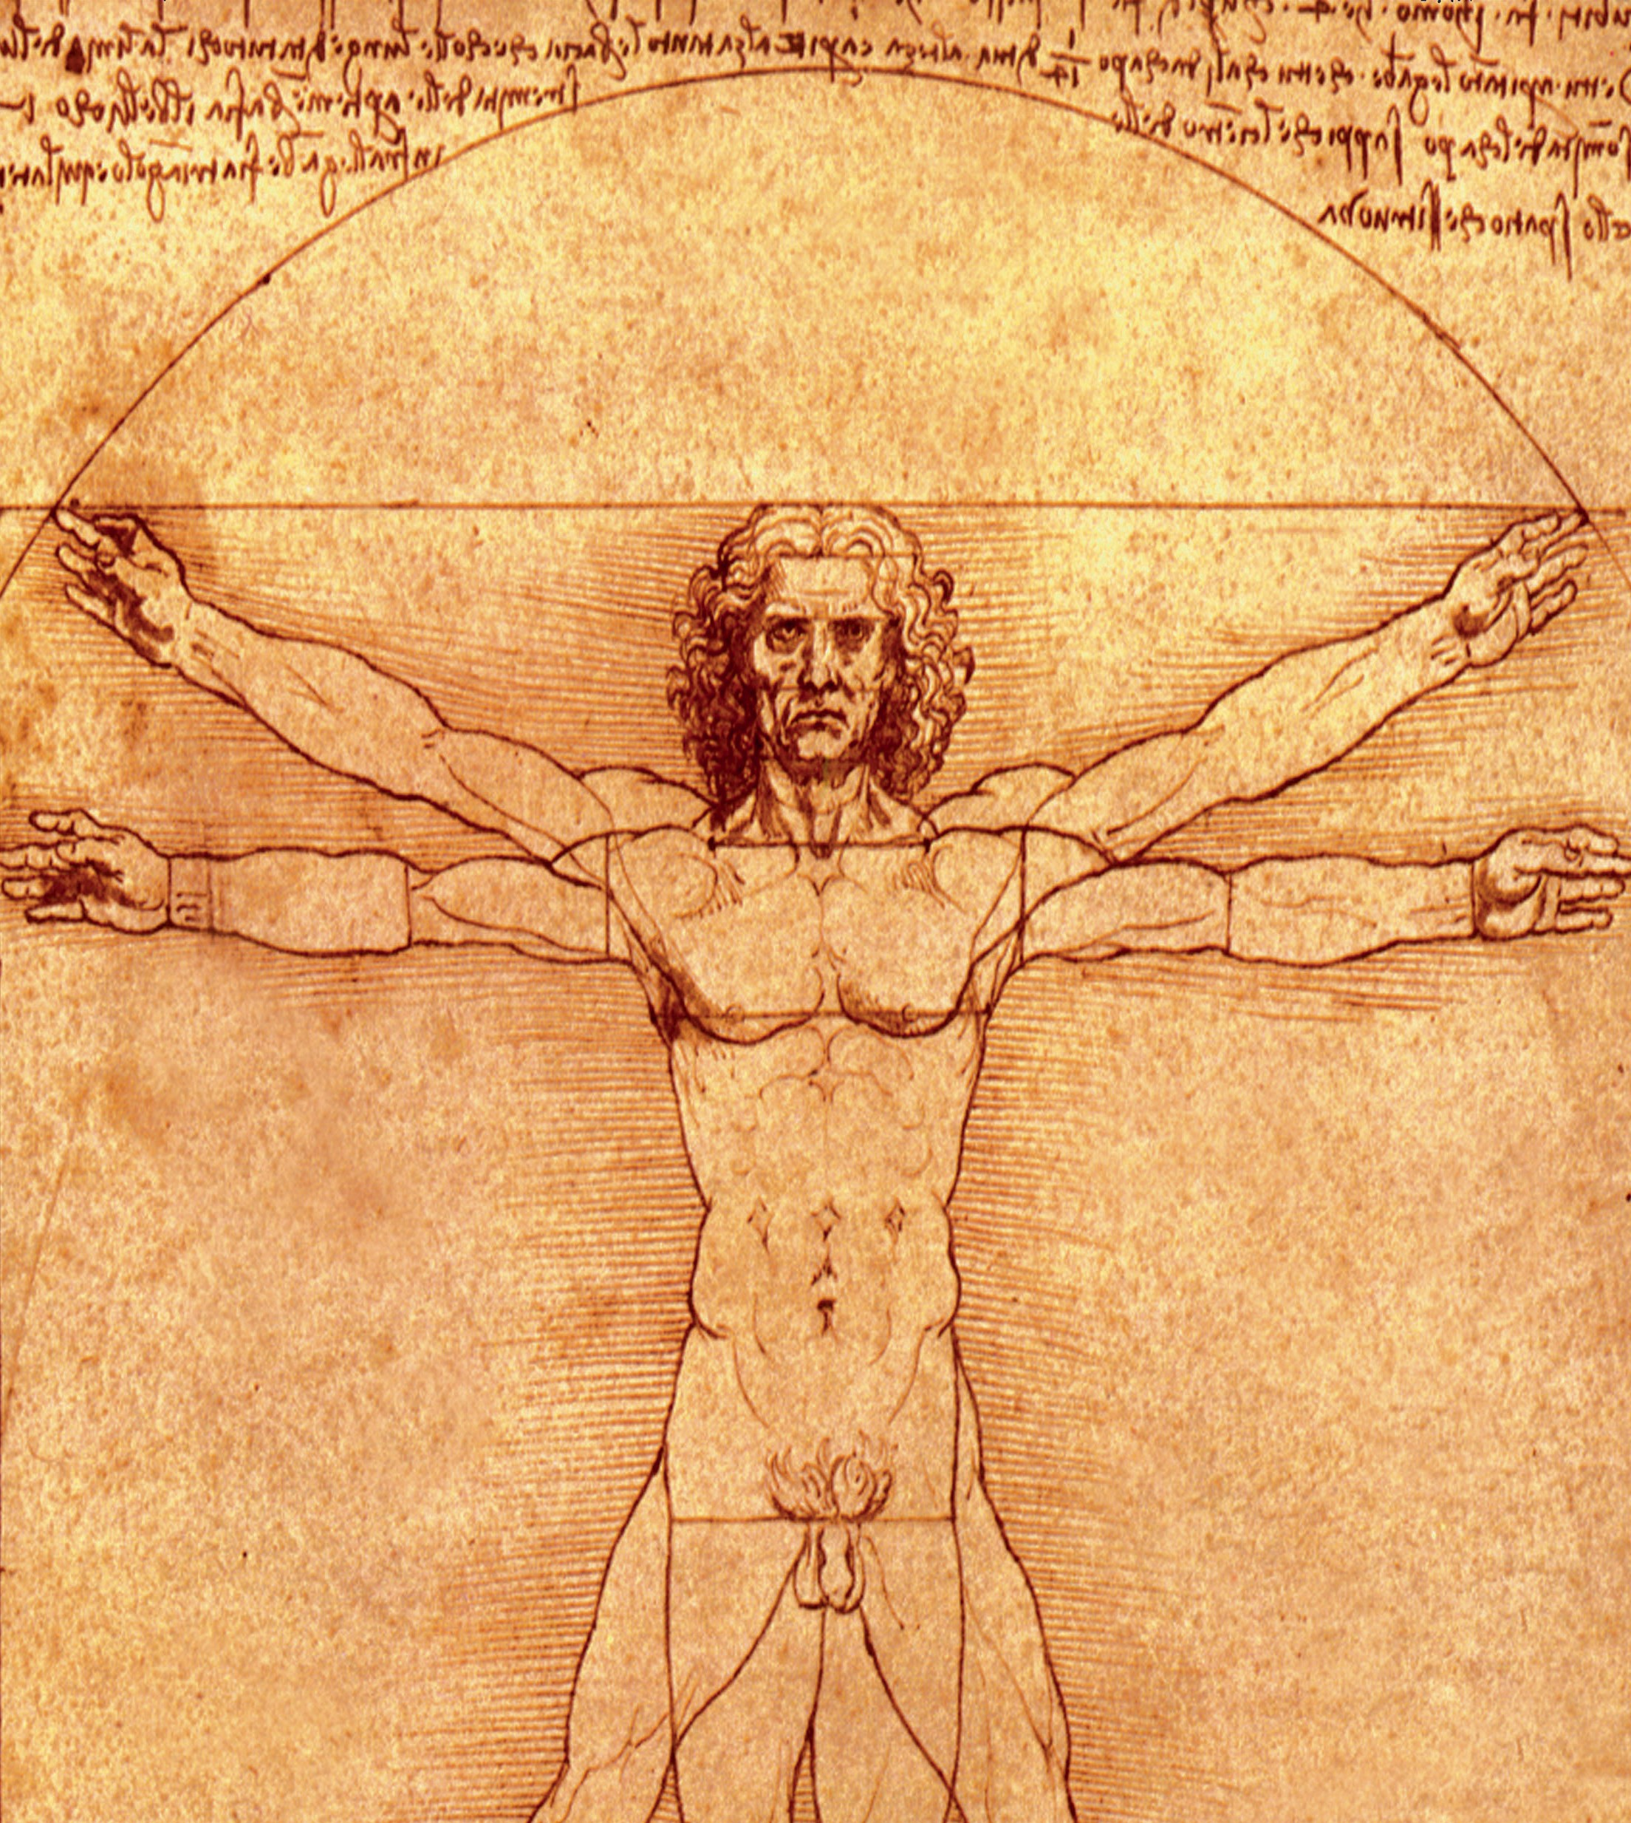

Course program

7th AOCMF Course—Advances in Operative Techniques in Oral and Maxillofacial Surgery (with Anatomical Specimens)

April 20–April 22, 2016 Vienna, Austria

Mission

Our mission is to continuously set standards in postgraduate medical education and to foster the sharing of medically guided expertise in a worldwide network of healthcare professionals to improve patient care in trauma or disorders of the musculoskeletal

system.

The AO principles of fracture management

Fracture reduction and fixation to restore anatomical

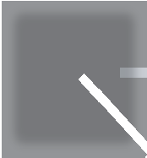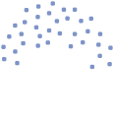

1

2

4

3

relationships.

Fracture fixation providing absolute or relative stability, as required by the “personality” of the fracture, the patient, and the injury.

Early and safe mobilization and rehabilitation of the injured part and the patient

|  |  |  |  |
| --- | --- | --- | --- |
|  |  |  |  |
|

as a whole.

Preservation of the blood supply to soft tissues and bone by gentle reduction techniques and careful handling.

Welcome

On behalf of AOCMF and your local and international faculty, I would like to welcome you to this AOCMF course.

AOCMF is a worldwide multi–specialty community that serves as the voice and professional resource for craniomaxillofacial trauma and reconstruction.

Our organization creates a forum for specialists who have common interests and enthusiasm in this field. It is our goal to encourage and inspire younger surgeons, such as residents, fellows, and early practitioners to pursue fulfilling careers in our field.

Education has always been a major pillar in AOCMF. Currently, more than 2,500 surgeons participate in over 80 AOCMF courses held worldwide per year. AOCMF Education is committed to remaining in the forefront of education and new developments as we strive to improve your educational experience with us.

We hope that your experience with us over the next few days will result in the acquisition of new knowledge, skills and understanding, which will translate into an improvement in the care that you are able to give your patients.

We also hope that, after attending this course, you will wish to develop a longer term relationship with AOCMF and become a member of our

community. Make this organization yours by bringing in your opinions and ideas. Enjoy the camaraderie of our network and help us maintain and expand the preeminent position that AOCMF enjoys worldwide.

Content

2 Mission

1. The AO principles
2. Welcome
3. Goal of the course

4 Target participants

4 Course objectives

1. Course description
2. Chairpersons

5 Faculty

5 Course organization 6 Day 1, April 22, 2015 7 Day 2, April 23, 2015 8 Day 3, April 24, 2015

9 Course logistics

1. Course information
2. Course registration
3. Course venue

Yours sincerely,

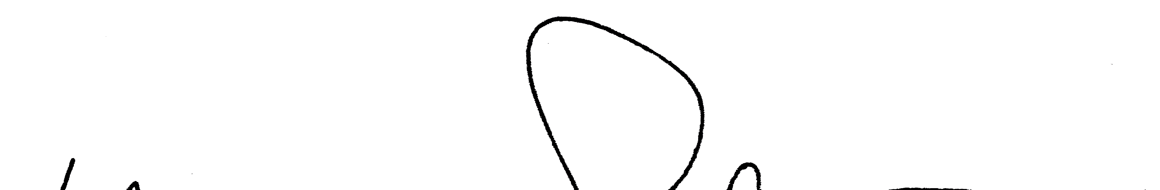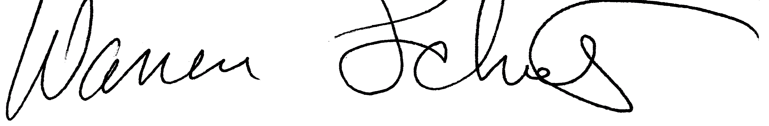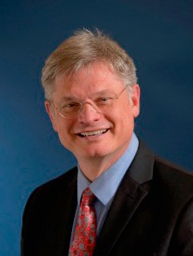

Warren Schubert

Chairman AOCMF International

Goal of the course Target participants

This course with practicals on anatomical specimens is designed to present and teach all essential operative procedures in oral and maxillofacial surgery.

We also offer you the chance to practice under expert guidance.

* Maxillofacial Surgeons
* Plastic and reconstructive surgeons
* Otolaryngologists
* Surgeons of related disciplines

Course objectives Course description

After the course, participants should be able to:

* + know how to perform the most relevant surgical approaches safely
  + be able to carry out the most essential operative procedures step by step
  + develop and/or enhance their surgical skills in a variety of operative techniques in oral and maxillofacial surgery
  + gain an improved understanding of complex anatomical structures

Course Concept: Practicals on anatomical specimens, Lectures

This three–day intensive course trains on fresh frozen ana- tomical specimens.

Each practical session will include a step by step introduction followed by an on–site demonstration. Participants will then perform the same technique on anatomical specimens.

The course is organized with 2 participants per anatomical specimen.

Course director Course chairs

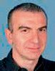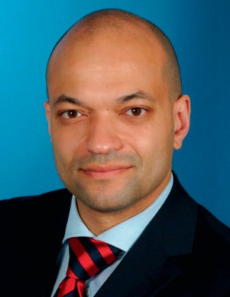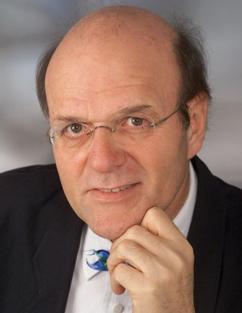

Christos Perisanidis

Vienna, Austria

Emeka Nkenke

Vienna, Austria

Rolf Ewers

Vienna, Austria

International faculty

|  |  |  |
| --- | --- | --- |
| Julio | Acero | Madrid, Spain |
| Thomas | Kofod | Copenhagen, Denmark |
| Günter | Lauer | Dresden, Germany |
| Nikolaos | Papadogeorgakis | Athens, Greece |
| S Mark | Taylor | Halifax, Canada |

National faculty

|  |  |  |
| --- | --- | --- |
| Rolf | Ewers | Vienna, Austria |
| Emeka | Nkenke | Vienna, Austria |
| Christos | Perisanidis | Vienna, Austria |
| Wolfgang P | Pöschl | Wels, Austria |
| Michael | Pretterklieber | Vienna, Austria |

Course organization CME accreditation

AO Foundation AOCMF

Sarah Rosalind Groves

Education Project Coordinator AOCMF/AOVET Clavadelerstrasse 8

270 Davos, Switzerland

Phone +41 81 414 25 52

Fax +41 81 414 22 80

Email [sarah.groves@aocmf.org](mailto:sarah.groves@aocmf.org) [www.aocmf.org](http://www.aocmf.org/)

An application has been made to the UEMS—EACCME for CME accreditation of this event.

The number of credit points or hours varies from country to country. The final information and number of credit points will be distributed with the course certificate.

Day 1, April 20, Wednesday, 2016

|  |  |  |
| --- | --- | --- |
| TIME | AGENDA ITEM | WHO |
| 07:30–08:00 | Registration |  |
| 08:00–08:20 | Welcome address and introduction | C Perisanidis E Nkenke  R Ewers |
| 08:20–08:40 | AO History, structure and membership | R Ewers |
| 08:40–09:00 | Introduction of the anatomical training lab | M Pretterklieber |
| Session I | Airway Management |  |
| 09:00–10:00 | Tracheostomy | E Nkenke |
| Session II | Neck Dissections |  |
| 10:00–11:30 | Supraomohyoid neck dissection | G Lauer |
| 11:30–12:00 | Coffee Break |  |
| 12:00–13:30 | Modified radical neck dissection | G Lauer |
| 13:30–14:30 | LUNCH |  |
| Session III | Facial Nerve and Parotidectomy |  |
| 14:30–16:30 | Facial nerve dissection | N Papadogeorgakis |
| 16:30–16:45 | COFFEE BREAK |  |
| 16:45–18:00 | Parotidectomy | N Papadogeorgakis |
| 18:00 | End of Day 1 |  |

Day 2, April 23, Thursday, 2015

|  |  |  |
| --- | --- | --- |
| TIME | AGENDA ITEM | WHO |
| Session IV | Rhinoplasty and Blepharoplasty |  |
| 08:00–10:00 | Open rhinoplasty | S M Taylor |
| 10:00–10:30 | COFFEE BREAK |  |
| 10:30–11:30 | Upper blepharoplasty | S M Taylor |
| 11:30–12:30 | Lower blepharoplasty | S M Taylor |
| 12:30–13:30 | LUNCH |  |
| Session V | Approaches to the Orbit |  |
| 13:30–14:30 | Transconjunctival approach | W P Pöschl |
| 14:30–15:15 | Transcaruncular approach | W P Pöschl |
| 15:15–15:30 | COFFEE BREAK |  |
| Session VI | Approach to the TMJ |  |
| 15:30–17:30  17:30 | Auricular approach End of Day 2 | W P Pöschl |

Day 3, April 24, Friday, 2015

|  |  |  |
| --- | --- | --- |
| TIME | AGENDA ITEM | WHO |
| Session VII | Orthognathic Surgery |  |
| 08:00–09:00 | Le Fort I osteotomy | T Kofod |
| 09:00–10:30 | Bilateral sagittal split osteotomy | T Kofod |
| 10:30–11:00 | COFFEE BREAK |  |
| Session VIII | Approaches to the Midface and Upper Face |  |
| 11:00–11:45 | Weber-Ferguson | J Acero |
| 11:45–12:30 | Zygomatic bone osteotomy | J Acero |
| 12:30–14:00 | Coronal approach | C Perisanidis |
| 14:00–14:15  14:15 | Certificates  End of Course |  |

Course logistics

Course Logistics:

AO Kurssekretariat

Mag.(FH) Sylvia Reischl

A-1026 Vienna

[Phone: +43 664 925 3869](tel://Phone:%20+43%20664%20925%203869)

Email: [reischl.sylvia@ao-courses.com](mailto:reischl.sylvia@ao-courses.com)

Course information

Evaluation guidelines

All AOCMF courses apply the same evaluation process, either ARS (audience response system) or paper and pencil questionnaires. This will help AOCMF to ensure that we continue to meet your training needs. In

some regions, CME accreditation is dependent on the participant’s evaluation results.

Intellectual property

Course materials, presentations, and case studies are the intellectual property of the course faculty. All rights are reserved.

Recording, photographing, or copying of lectures, practical exercises, case discussions, or any course materials is absolutely forbidden.

Security

Security check at the entranceof the building. Wearing of a name tag is compulsory during lectures, workshops, and group discussions.

No insurance

The course organization does not take out insurance to cover any individual against accidents, thefts or other risks.

Mobile phone use

Mobile phone use is not allowed in the lecture halls and in other rooms during educational activities. Please be considerate of others by turning off your mobile phone.

Transportation

Not provided for participants

Dress code

Casual

Course language

English

Course registration

Please register online at

[http://xxxx](http://VIENNA0415.aocmf.org/)

Attention! The number of participants is limited to 18 participants

Course fee

Euro 1270,--

Includes course fee, course bag, coffee breaks, lunches, and dinner on Thursday, April 21, 2016.

Course venue

Medizinische Universität Wien Anatomisches Institut (Center for Anatomy) Währinger Straße 13

1090 Wien

https://[www.google.at/maps/place/Universität+Wien+Anatomisches+Institut/](http://www.google.at/maps/place/Universit%C3%A4t%2BWien%2BAnatomisches%2BInstitut/)

@48.21773,16.358587,15z/data =!4m2!3m1!1s0x0:0x13c534ca032ef884

Improving patient care worldwide

AOCMF membership

Participation in the AOCMF community guarantees life-long learning opportunities and continuous professional development

AOCMF Videos

Make use of our multimedia teaching and learning materials

Online access to scientific journals

Stay up to date on the latest

practices and advancements in the field of craniomaxillofacial surgery

Online case discussions

Participate in the interactive exchange

AOCMF Journal

Craniomaxillofacial Trauma and Reconstruction publishes primary and review articles covering all aspects of surgery of the head, face, and jaw

Available free of charge to all AOCMF members

AO Publications

Take advantage of special discounts and free offers for AOCMF members

AO Surgery Reference

See surgical procedures explained

of professional opinions step by step

of professional opinions

step by step

AOCMF portal

Your window to the AO world Witness the global

reach of our CMF community

[www.aocmf.org](http://www.aocmf.org/)

Precondition

Precondition

The prerequisite for becoming

a part of the AOCMF membership community is attendance at one certified AOCMF education event

hip

e

nt

Membe ship types AOCMF Affiliate (CHF 40) no prerequ site

AOCMF e-Member (CHF 40) AOCMF Member (CHF 75)

ship types

AOCMF A

no prerequi

AOCMF e

AOCMF

Member

Providing a common ground for excellence in craniomaxillofacial surgery

AO Foundation

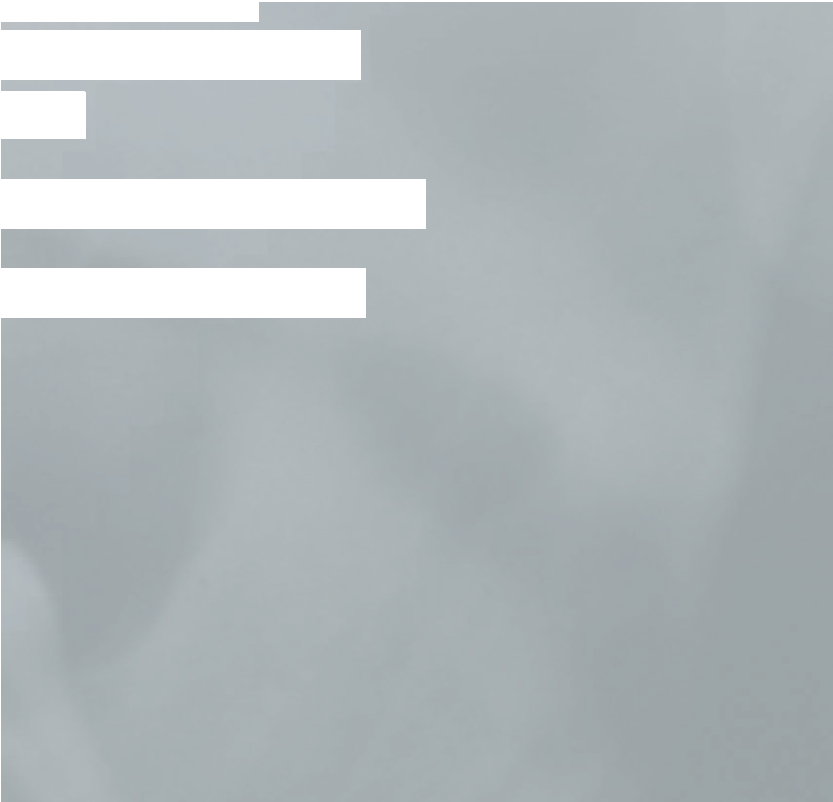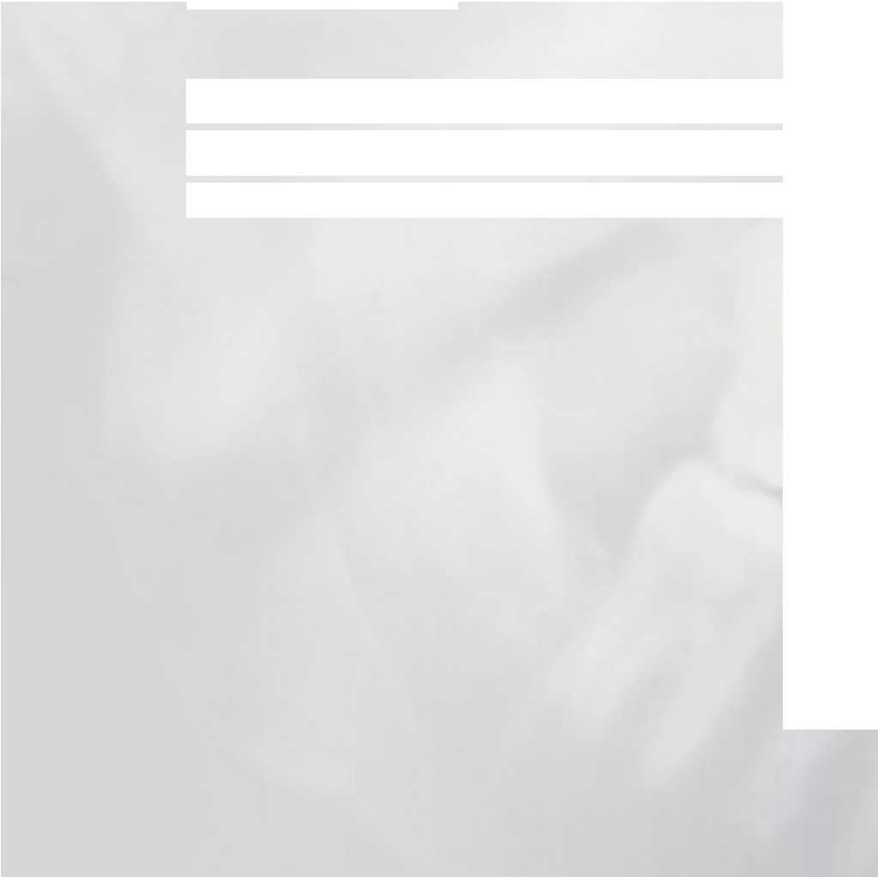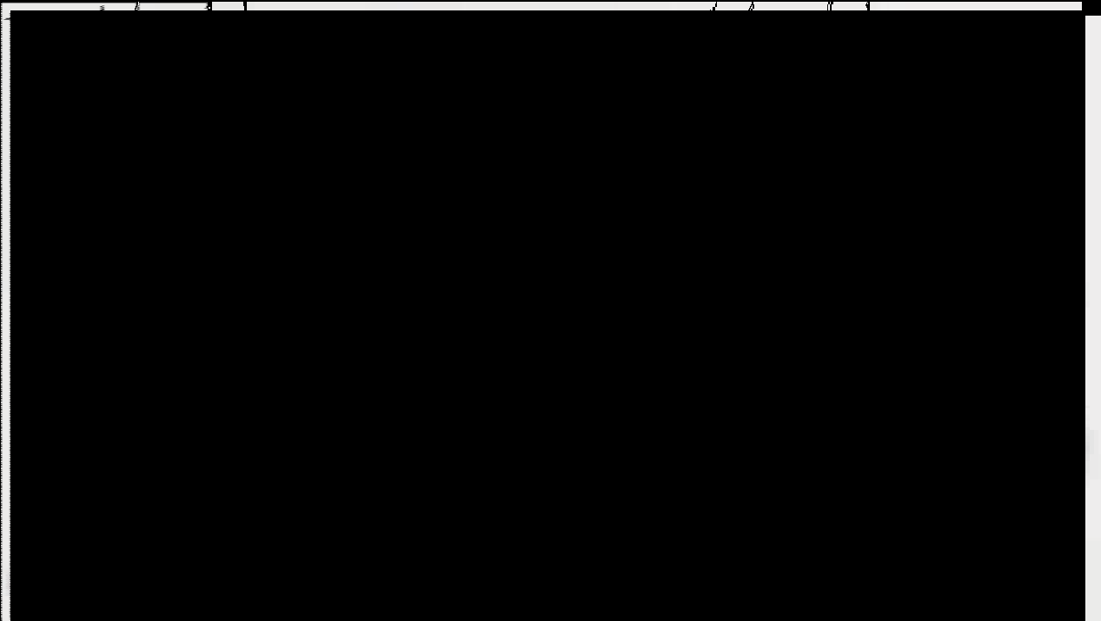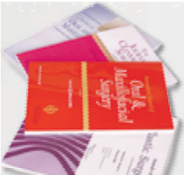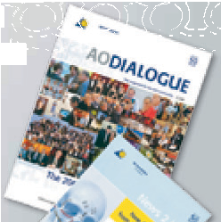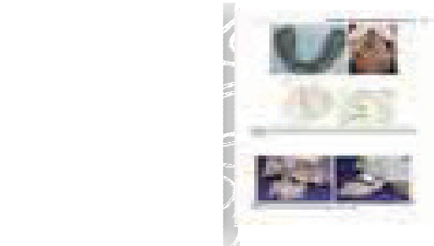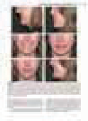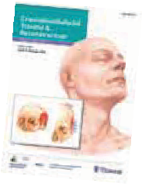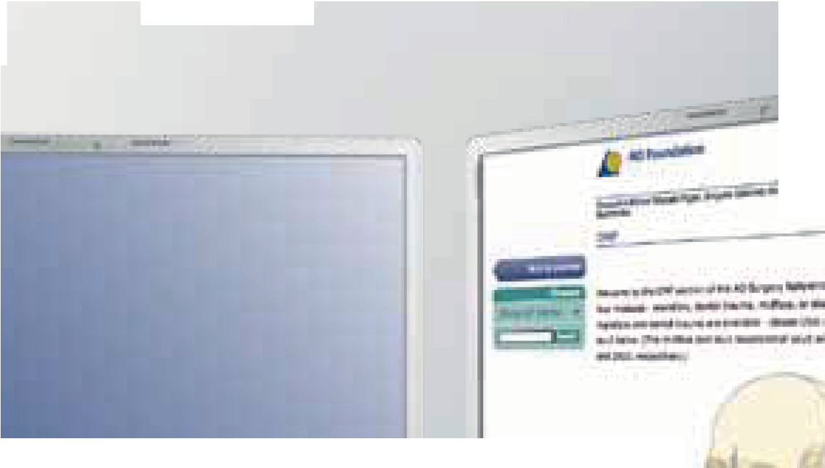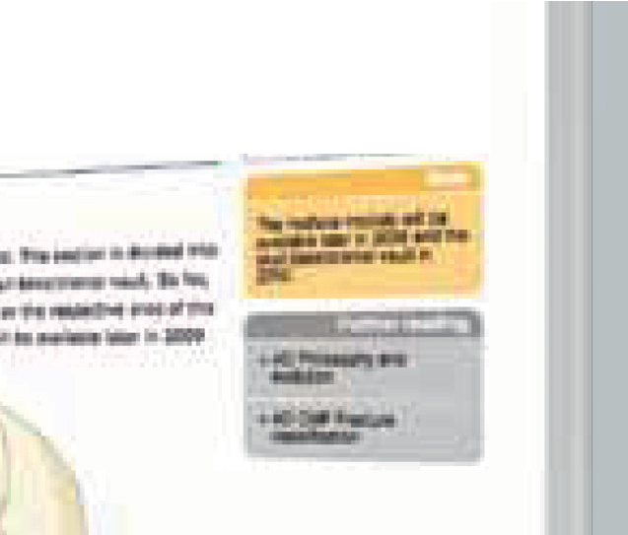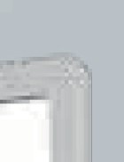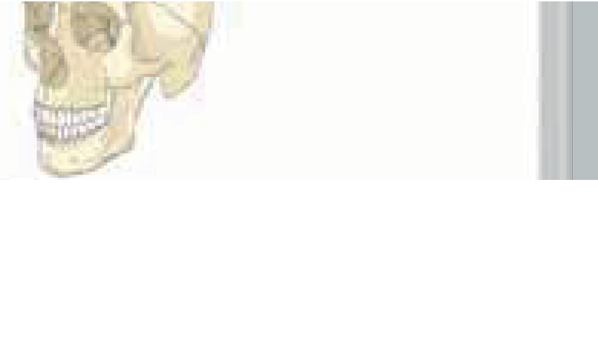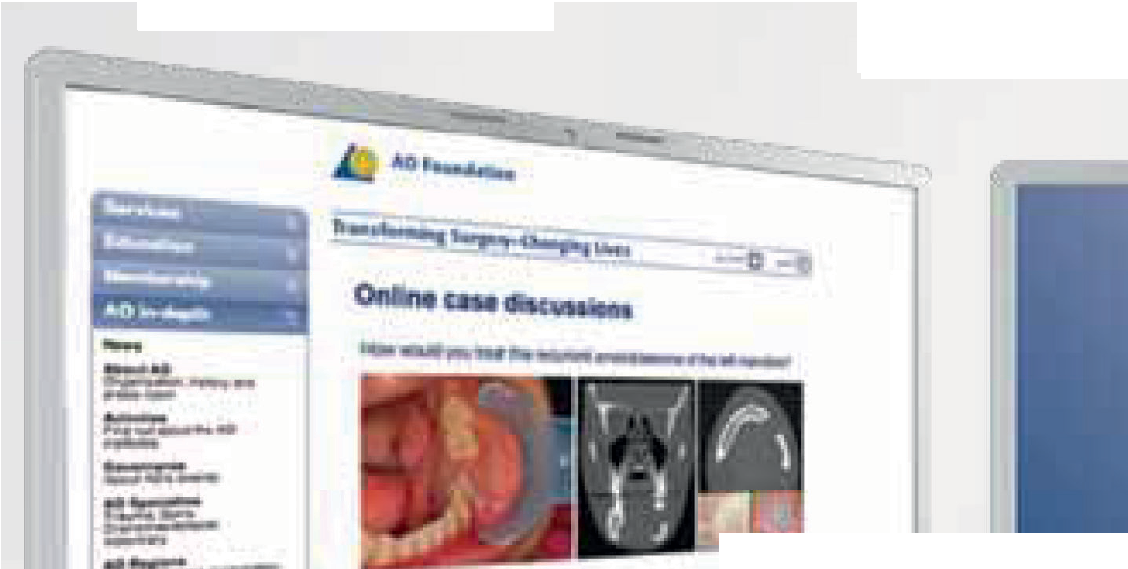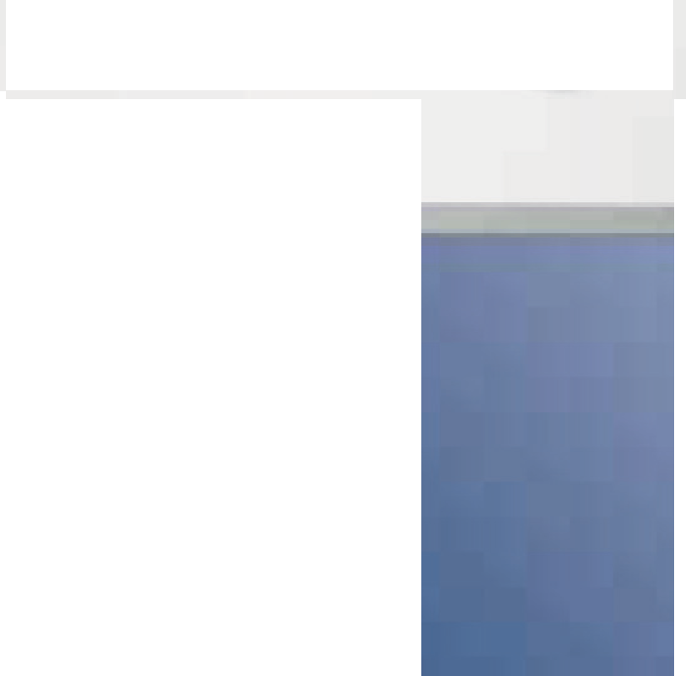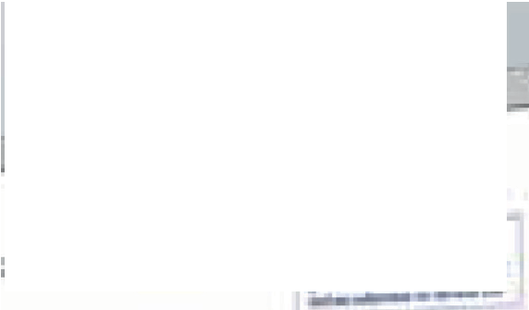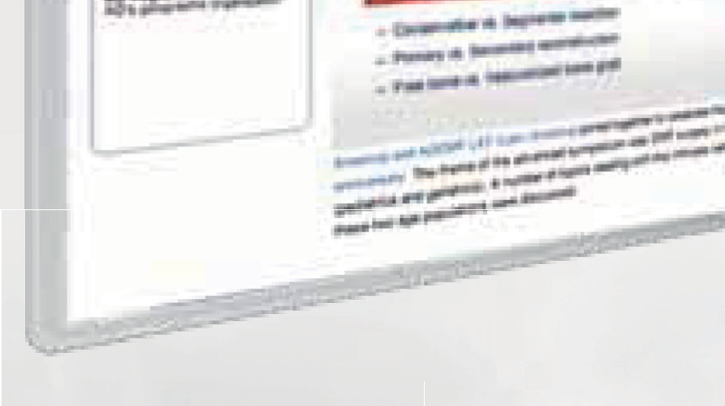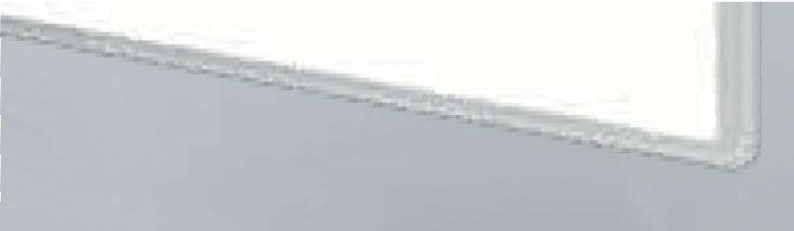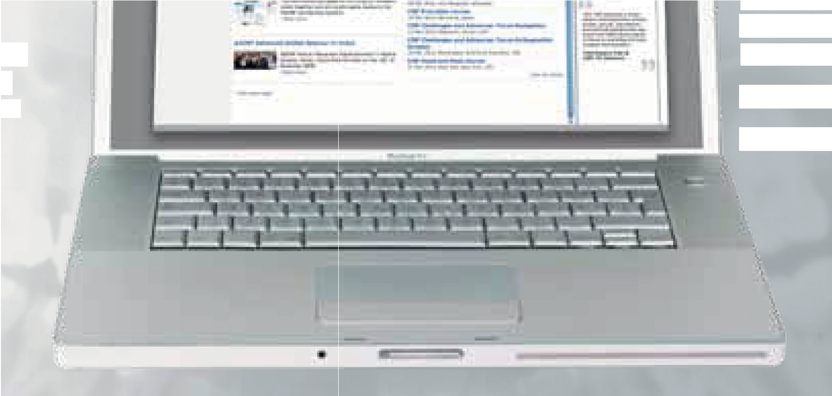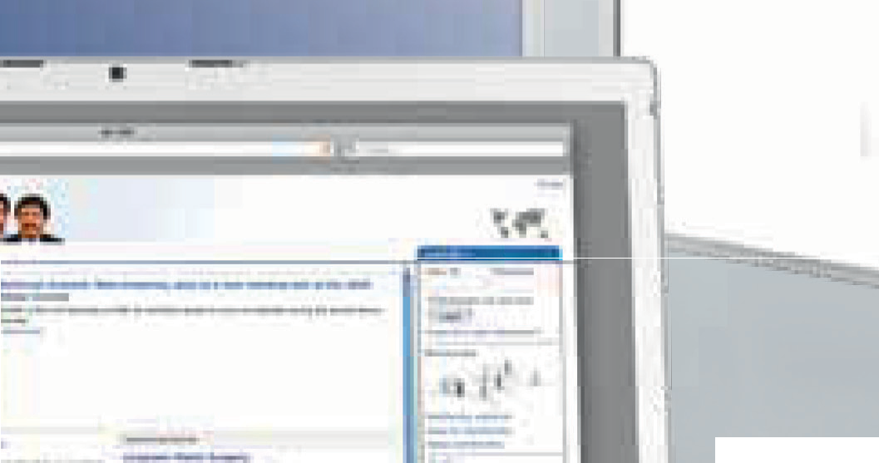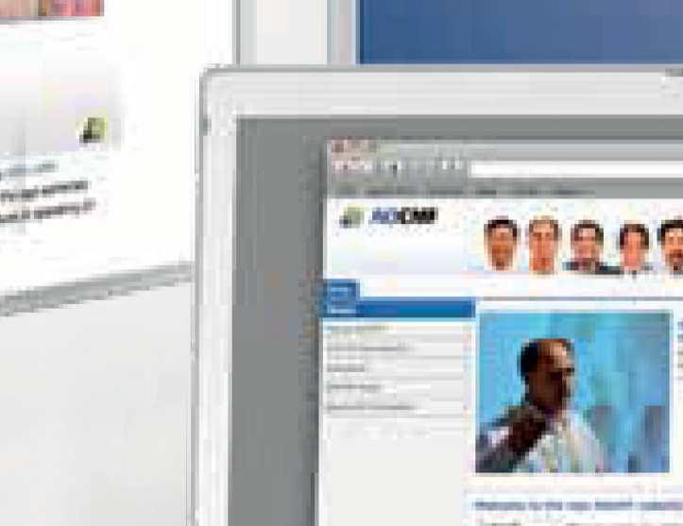

AOCMF Clavadelerstrasse 8, 7270 Davos, Switzerland

Phone +41 81 414 25 55, Fax +41 81 414 22 80, [info@aocmf.org](mailto:info@aocmf.org)

Logistics and support provided by an educational grant from DePuy Synthes.